# Welcome to DotNet!

## What is C#?

C# is an Object-Oriented Programming Language

C# is like Java... but different

C# is comparable to other languages but is better at doing certain things well. Other languages are better at doing other things well. This Q&A addresses certain Advantages C# has as a language to work in: <https://softwareengineering.stackexchange.com/questions/125712/for-what-reasons-should-i-choose-c-over-java-and-c>

You can gain familiarity of C# syntax with the code on the next page:

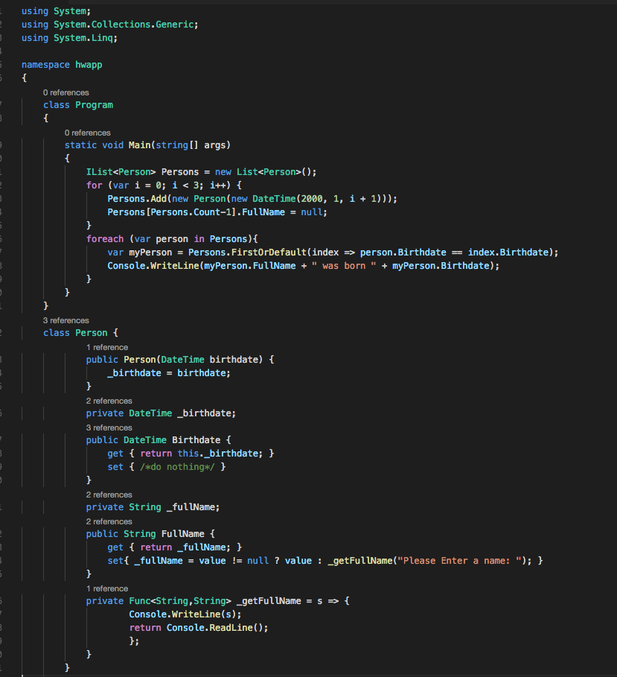

### So what is Object-Oriented Programming (OOP)?

Object-Oriented Programming is where Objects come first to wrap and “encapsulate” business models. Object-Oriented Programming is about using Objects to hold the state of the information and changing state with function calls.

Functional Programming is where Functions are first and foremost furnishers of information. Functional Programming is about using Functions to obtain information and maintaining state of the data objects.

i.e. If you were writing a Bank Account Statement in OOP vs if you were writing a Bank Account Statement in FP:

**Functional Programming**

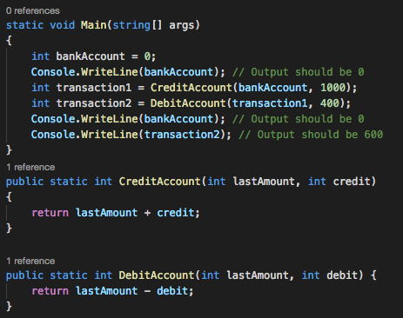

**Object-Oriented Programming**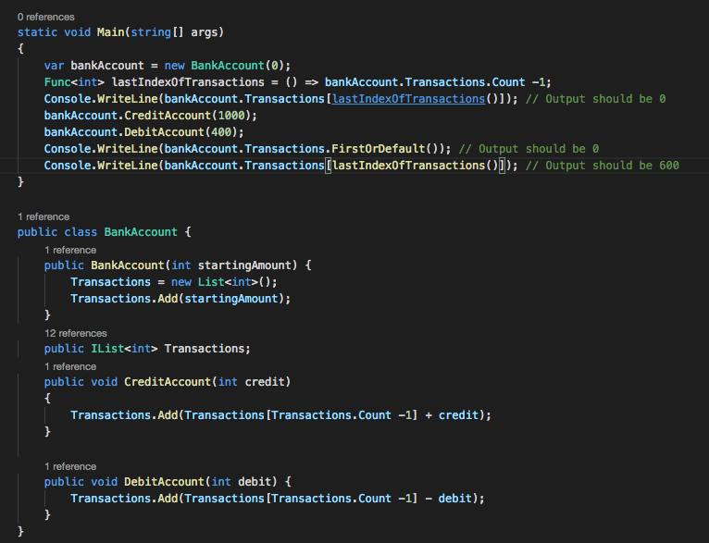

To explain this code–

The first image (FP) shows that a scenario in which we create functions, and those functions return values after performing calculations. We can see that a function call is made twice with the same input at multiple places in the code, and the resulting output is the same.

The second image (OOP) shows a scenario in which we create Objects that hold multiple transactions in a “List”. We then use the functions that exist on object to add Transactions to the “List” and change the state of the object. We can see that a function call is made twice with what appears to be the same input. But since the state of the object changes, the output of the same function call changes as well.

Object-Oriented Programming is better than Functional Programming in the same way that a Hammer is better than a drill – It’s only better in certain circumstances. Additionally, you can hammer a steel molly into a wall and then use a drill screw it in further to give your wall additional support for whatever you’re hanging, just like you can mix OOP with FP.

C# is a language that’s Primarily Object-Oriented in purpose. From the above examples you can see that we used C# for both Object-Oriented and Functional Behavior.

***Think about it...* Object-Oriented Programming languages can be used functionally, but functional languages can be used with Objects. Frameworks like AngularJS and jQuery strive to apply object-oriented concepts to the primarily functional JavaScript Language to have the benefits of both languages.**

## What is .NET?

.NET is a platform, or a complete programming environment. It includes the language, the runtime intricacies, the components, and all associated libraries that go with the language.

***Think about it...* Silverlight is another platform which uses C# and was used to build Netflix at some point in time. C# is not .NET, but C# is built in a way that it works very well with .NET**

## What is the difference between MVC and WebAPI?

### What is Graphical User Interface (GUI)?

GUI is an interface between a person and a computer. When viewing an Application a user will see buttons to click and information presented to them to absorb and Graphical User Interface is just that – a visual medium through which users can interact with an application.

### What are Restful API services?

RESTful describes Representational State Transfer, which is providing communication between computer systems over the internet by using HTTP commands (GET, PUT, POST, DELETE, etc...) so that communication can occur easily and with pre-defined behaviors.

API is Application Programming Interface, a set of definitions, tools and behaviors that take information from another computer through a request... and does something with it.

In a sense, a RESTful API is just a computer program that receives HTTP requests and then does something with the information it receives.

Just as a graphical user interface can be used to transfer data back and forth between person and machine, API is used to transfer data back and forth between machine and machine.

### What is MVC?

MVC is one of many architecture patterns used to construct UI. It stands for Model-View-Controller.

* Model holds the information and the state of the information.
* View is the screen you see.
* Controller controls the data

MVC is one of many different types of software architectural patterns for implementing a user interface:

Some others include:

* MVVM (Model View View-Model)
* MVP (Model-View-Presenter)

### Now what are ASP.NET MVC and WebAPI?

WebAPI is the .Net version of a pre-built API, with the primary purpose of being a Restful API. You can make changes to it, but you ask the computer create an API and it gives creates an application with all the libraries needed along with a pre-defined “best practices” code structure.

MVC is the .Net version of a pre-built UI, with the primary purpose of being a UI. Just as WebAPI will give you what you need for an API, MVC builds you a new UI with all of the libraries needed and a pre-defined “best practices” code structure.

***Think about it...* ASP.NET MVC can be used as an API, but WebAPI is a pre-defined framework built to make API a lot more efficient, effective and easy to write.**

## What is Javascript? HTML? CSS?

HTML is boxes, and boxes within boxes, and next to boxes. HTML describes boxes, their neighboring boxes and their children boxes. This is a sample of HTML:

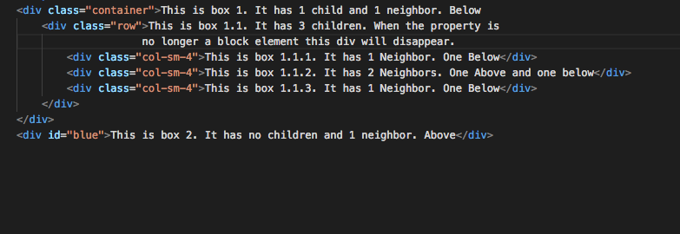

As you can see you can add descriptors to the boxes. You can put classes on them to attach identification to many, or you can attach an id to a box, and each id can only be used once. But since there is no CSS on this page the boxes have no structure. They are just boxes within boxes.

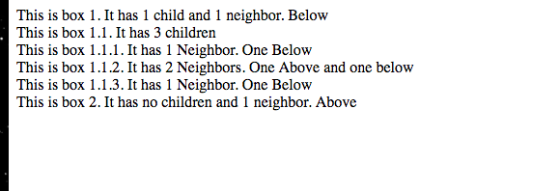

CSS describes the boxes. It says that this box is blue, and that box is over there. Watch what happens when we import Bootstrap – a CSS framework built by Twitter, and when we create our own CSS stylesheet:



As you can see this is very different than it was before. HTML defines page structure, but CSS makes it pretty.

Javascript tells the boxes what you want to do with them. You could click a box, move your mouse and have the box follow your mouse. Or you could have boxes hidden, and then when you scroll down on the screen they suddenly become visible. Javascript defines the behavior you want the boxes to exhibit.

***Think about it...*There are HTML Elements, H1, Strong, H3, that aren’t “div”. These elements define boldened elements, or elements with bigger font. The reason we say that HTML defines the Page Structure is because H1 should be a placeholder – but how big should it be? If you make an H1 element then HTML5 will automatically apply a font-size of “2em”, a unit of size that changes in relation to the font-size of the document. However, this is CSS that is defined as part of HTML5 specifications. HTML5 defines best-practices for how to structure a page for accessibility, SEO, User experience and much more.**

## What is Bootstrap? LESS? SASS? SCSS?

Bootstrap is a Framework for CSS. You use pre-defined attributes (like “classes”) on HTML elements instead of styles embedded in a view. These attributes define the styles for you so you can apply CSS through higher-level concepts instead of lower-level code. Instead of saying “What is a font-weight:bold; font-style:italic” You could have a “Think About It” concept so that all boxes that contain a “Think About It” element show the same properties.

LESS, SCSS and SASS are CSS compilers. They let you shorten the amount of time in writing your CSS and make them more adaptive to change.

***Think about it...*If you build a theme with a “Main Color” and you use CSS to change all elements that contain the “Main Color” to green, then when you rebrand your company you have to find all of those elements and change them to Blue...**

**But if you set variable @main-color=”Green” and then you write into your SCSS {*color: @main-color*}**

**When you re-compile the code after changing @main-color to blue, then all the places you see @main-color will be replaced with blue.**

### What role does Javascript play in .Net Development?

JavaScript is the only “programming language” that runs in the browser, so a full-stack developer needs to know JavaScript if they want to have an interactive front-end.

## What is SQL and why does every job ask for it?

### SQL is Structured Query Language.

It’s a communicative language to some and a functional language to others. It requests information from the database.

The reason so many jobs ask for it is because Data controls everything nowadays. Without Data you don’t know what you’re getting paid, how your marketing is going, etc. SQL Databases allow paper processes which people would pass back and forth to each other to be a lot more accessible.

***Think about it...*What does this mean?**   
SELECT FName, LName   
FROM Employees   
WHERE HireDate > DATEADD(GETDATE(),y,-1)

**The above statement says “Select FirstName and LastName from a series of employees where their HireDate is Greater than Today’s Date minus a year. In other words, it’s saying Get the first and last name of all employees that have been hired within the last year.**

**This is why some view it as a communicative language, because at its most basic form it’s very easy to read and very self-documenting.**

### What role does it play in DBA?

A DBA is a Database Administrator. They use a lot of SQL to maintain their Databases, but they can also use a lot of GUI tools. Their SQL is more oriented towards creation of indexes, triggers to create audit tables (for example if you delete data how do you preserve it for audit assessment, and for how long?) and permissions.

### What role does it play in SQL Developer?

A SQL Developer is the grey area between DBA and Back-End Developer. A SQL Developer does a lot of what a DBA would do when companies don’t have the resources for a proper DBA. Or a SQL Developer could be used to write Stored Procedures, Functions and Triggers so that API developers don’t even need to use ORMs or SQL when companies have enough resources to separate out Database Behavior from Application Behavior. SQL Developer is a very niche position, but they *generally* need to know more SQL than Application Developers AND DBAs combined.

### What role does it play in .Net Development?

Generally it doesn’t. Many shops with full-stack development use ORMs and Micro-ORMs (defined in “What is Entity Framework?”). SQL can be used to find information from the database while working support tickets or while testing new features, but when using the live databases many companies have a tight lock on what can and can’t be used.

## What is Entity Framework?

Entity Framework is an ORM. NHibernate is also an ORM. NPOCO is a Micro-ORM

### What is an ORM?

ORM is Object Relational Mapper. You specify a business unit. ORM will then build tables around that business unit. It will create code that will map to the database tables for you. It has many features of security and powerful querying capabilities. It works for some, but others find it too complex in the queries it runs, so they turn to Micro-ORMs...

### What is a Micro-ORM?

A Micro-ORM is like an ORM... but it puts more work on the User. An ORM can create databases, but a Micro-ORM may be dependent on a table that already exists. It will ensure protection against SQL Injection, but will require that your write your own queries.

***Think about it...*If your Business unit is an Employee, you know an Employee has a First Name, a Last Name, a Birthdate, an Age and a Hire Date. You don’t need to store Age because you can calculate that from Birthdate. So you can make rules on the ORM to say “When my code contains an Employee, and I have to write this to the database, ignore Age”.**

## So I’ve heard about “Dependency Injection” What is it?

Dependency Injection is a form of Inversion of Control (IoC). IoC suggests that if you have a component of code, all dependencies, configurations and lifecycles should not be the concern of the component, but rather it’s caller.

As an example, John leases a motorcycle.

* The Motorcycle has an engine, so the Engine is a Dependency
* The Motorcycle is blue, so the Blue paint is a Configuration
* The Motorcycle lease is 2 years, so the Lease Term is the Lifecycle

A Motorcycle exists in a Motorcycle Shop. It is built in this shop. The Motorcycle shop is the caller of the Motorcycle. The Motorcycle doesn’t create its own engine, so the Motorcycle shop passes in the Dependency. The Motorcycle can’t decide its own paint job, so the Motorcycle shop passes in the Configuration. The Motorcycle can’t decide how ownership is being handled, so the Motorcycle shop decides the Lifecycle.

In this example we lease to John, but where does John come from? The Motorcycle shop doesn’t create its customers, they must be passed in so it can pass Motorcycle and a contract to John.

Dependency Injection takes care of the “dependency resolution” portion of IoC. You can’t create an object without declaring and passing the dependencies in.

***Think about it...*An object doesn’t create its own dependencies, configurations or lifecycles, otherwise it’s not clean code. We like to call Dependency Injection the Hollywood Principle -- “Don’t call us, we’ll call you”.**

## What is Test Driven Development (TDD)?

To understand TDD we must first understand...

### What is Unit Testing... and why and how is it done?

Unit testing is testing a unit of code to ensure that it works. When writing a unit test, a developer takes a unit of code to test, mocks data that the code should test, and then runs that unit of code to make sure that they get the result they expect. It could pass or fail, but as developers we need to make sure if our code fails, it fails gracefully.

Unit testing is done to ensure that we’ve accounted for bugs or fixed them. But having Unit Tests does not mean that our code is perfect. They could fail integration tests...

### What is Integration Testing... and why and how is it done?

Integration Testing is similar to Unit Testing, but it ensures that your code works. A Unit Test can pass, and another Unit test can pass, but if those 2 components fight each other then your code is considered broken.

Type into your favorite search engine: “2 Unit Tests, 0 Integration Tests”.

One of the videos you will find is of drawers that open and close. Each Drawer works separately, but because of their placement in a corner and the length of their handles neither of them work.

Another video you will find is a hand-dryer in a bathroom above a waste bin. A person can dry their hands with a paper towel and throw it in the waste bin, or they can use the hand-dryer. But if they try to toss the trash in the waste bin the dryer starts and blows it out of the waste-bin.

Both Unit Tests and Integration Tests only scenarios a developer can imagine, or find by powering through their software and trying to find bugs however they can manage (Exploratory Testing).

### What is Continuous Integration?

Continuous Integration is a development practice that requires developers to integrate their solutions into a shared repository several times a day. Each time they check in their code, a system will compile the code to ensure it compiles correctly, run automated tests to ensure all the tests pass, and then if all tests pass it can deploy code immediately or wait until a set time. This practice is done to catch problems with deploys long before they push code to production.

### So Finally... What is Test-Driven Development?

Test-Driven Development is when you write your unit tests, and architect the code in your mind. All of the unit tests will fail, and then you write your code so that your unit tests work. It’s a way of producing less error-prone bugs and reducing the QA Feedback loop.

***Think about it...*In the motorcycle example of Dependency Injection, a Motorcycle Shop can pass in any engine, as long as that engine meets certain criteria. It must have certain dimensions, and it must connect in some way. Also, when you power it on it must return a behavior. Which means you can give it a test engine, to ensure that the rest of the vehicle works as expected without using the engine you plan to give to the customer, since you want it to be clean. This is a very useful in Unit and Integration Testing.**